

Walchand College Of Engineering, Sangli,
(An Autonomous Institute)

Department Of
Computer Science and Engineering

B.Tech Project-2 Report On

Who Is There?

Ajay Navgire 2018BTECS00006
Tulsi Galande 2018BTECS00004
Aditya Nanoskar 2018BTECS00048

Under the Guidance of

Prof. Anil Surve Sir
Guide
Computer Science & Engg.
Dept. WCE, Sangli.

2021-2022

Walchand College Of Engineering, Sangli,
(An Autonomous Institute)

Department Of
Computer Science and Engineering

CERTIFICATE

This is to certify that the Project Report entitled, “WHO IS THERE? “Submitted by Ms.Tulsi Galande, Mr. Ajay Navgire, Mr. Aditya Nanoskar, to Walchand College of Engineering,Sangli, India, is a record of bonafide Project work of course final year project-2 carried out by them under our supervision and guidance and is worthy of consideration for the award of the degree of Bachelor of Technology in Computer Science & Engineering of the Institute.

Prof. Anil Surve Sir Dr.M.A.Shah Guide HOD
Computer Sci. & Engg. Computer Sci. & Engg.
WCE, Sangli WCE, Sangli

Acknowledgement

We would like to place on record our deep sense of gratitude to Mr. Anil Surve Sir, Computer Science Department Walchand College of Engineering Sangli, for his generous guidance, help and useful suggestions.

Declaration

I hereby declare that work presented in this project report titled ”WHO IS THERE” submitted by me in the partial fulfillment of the requirement of the award of the degree of Bachelor of Technology (B.Tech) Submitted in the Department of Computer Science & Engineering, Walchand College of Engineering, Sangli, is an au- thentic record of my project work carried out under the guidance of Mr.Anil Surve Sir, Computer Sci.& Engg. WCE, Sangli

Date:31/05/2022
Place:Sangli Ajay Rajendra Navgire
2018BTECS00006
Tulsi Rajaram Galande
2018BTECS00004
Aditya Uday Nanoskar
2018BTECS00048

Table Of Contents

- Project title
- Abstract
- Introduction to Prometheus
- Problem statement
- Methodology
- Testing
- Results and Discussion
- Project Artifacts(SRS , Test Cases, UML Diagram, Source code, setup etc.)
- Conclusion and Future Scope
- References

1. Project title :

WHO IS THERE?

2. Abstract :

In this paper we have proposed guest recognition system using face detection for security purpose. Implementation of the system is for monitoring whether any unknown person is entering in to the room of user. We are going to send notification containing name, date, photo on the user’s phone. For software coding tkinter, CV2, sklearn, pandas libraries are used. In order to get accurate and clear picture of an intruder we have used face_detection library for face detection. As soon as the person enters near the door, pi camera captures the image and face detection process is done then if it matches with database images then a message with the picture of a person, name and date and time will be sent to the registered mobile if person is not in data set then message with photo of unknown person will be sent.

3. Introduction and Literature survey :

Nowadays, as the technology is increasing, facilities for human beings are increasing. In day to day activities, life of people has become very easier with the incorporation of many technologies. On the other hand, it also creates security issues. The traditional door locks have a problem that almost anyone can break and enter into your house. Hence it is a great challenge to overcome these problems. In general, in order to secure home, people make use of CCTV. Images will store in the database, so that the action can be taken when any suspicious incident happens. This type of approach is a passive. But there is a need for an active approach. This type of approach is nothing but where actions can be taken immediately as soon as a security threat occurs.

Hence, Face is the representation of one’s unique identity. So here proposing an application using face recognition for purpose of identifying the guest and sending notification on user’s mobile phone.
At the end of project we will able to perform following tasks:
1. Recognition of guest/unknown person
2. Send notification to user

4. Problem statement :

To design guest recognition system using face detection and send the notification to the user of system containing guest image, data and name of guest if present in data-set.

5. Methodology:

Approach 1. Using Haar Cascade Algorithm:
Haar cascades is a machine learning based approach where a cascade function is trained with a set of input data.
Haar Cascade is a machine learning object detection algorithm used to identify objects in an image or video.
It is a machine learning based approach where a cascade function is trained from a lot of positive and negative images. It is then used to detect objects in other images.

Approach 2. Using face_recognition library:
Find faces in pictures
Find and manipulate facial features in pictures
Identify faces in pictures

Then use push-bullet for sending notification to the user of system containing image of guest, date and name of guest

5.1. Testing:

In testing perform operations like deletion of record, insertion of new images and sending notification for correct guest. We take 20 guest images and store that images in folder and check working of notification functionality.

6. Results and Discussion:

We are able to capture guest image and identify weather the guest is known or unknown and after that send the notification to the user of system.

Below are screenshot of our system:
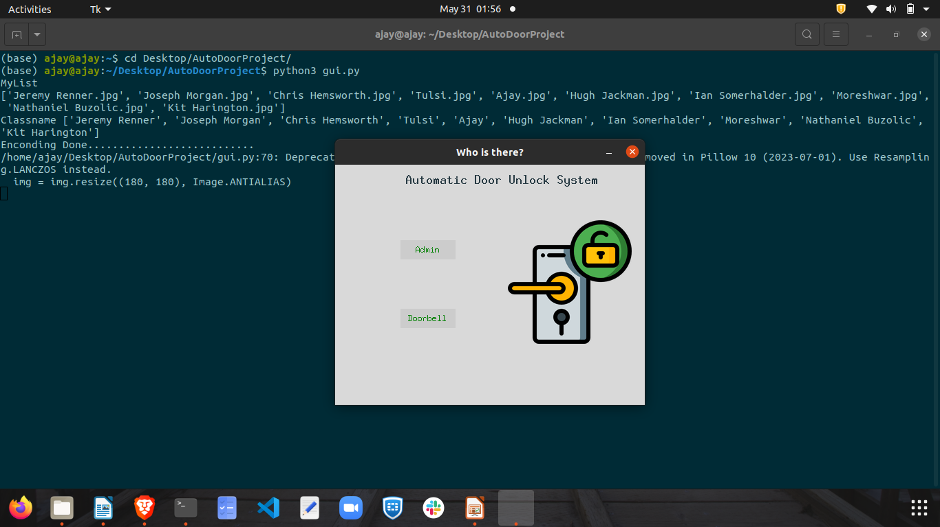

Fig.1.1 Home page of application

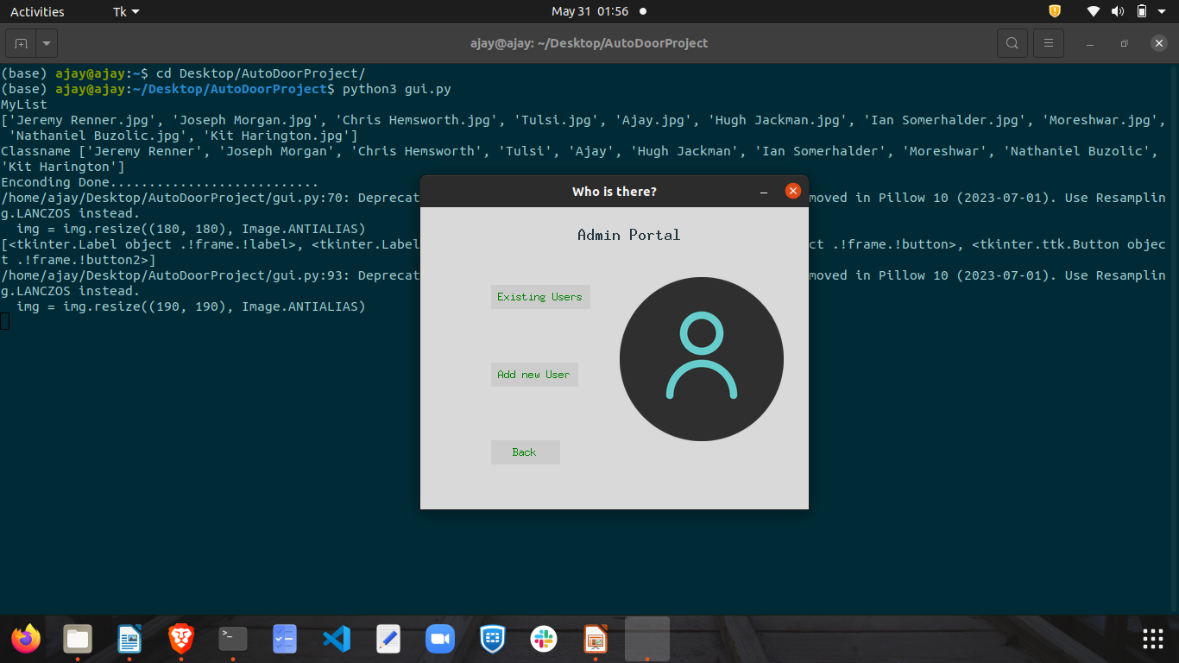

Fig.1.2 Admin portal of application

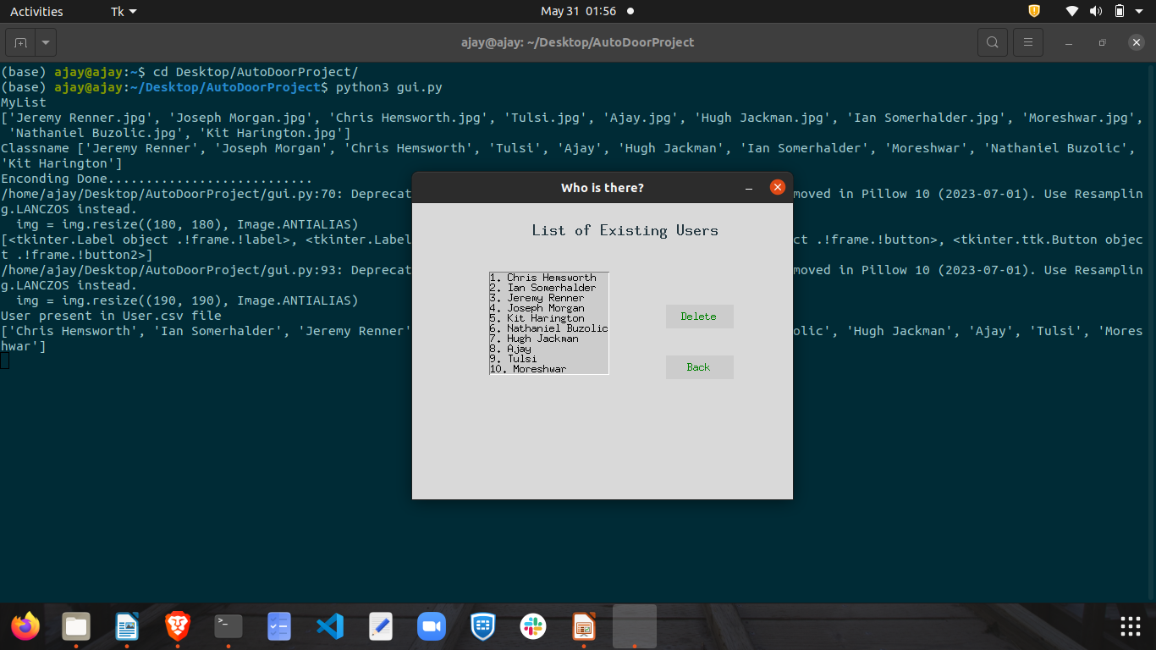
Fig.1.3. Show list of guest images present

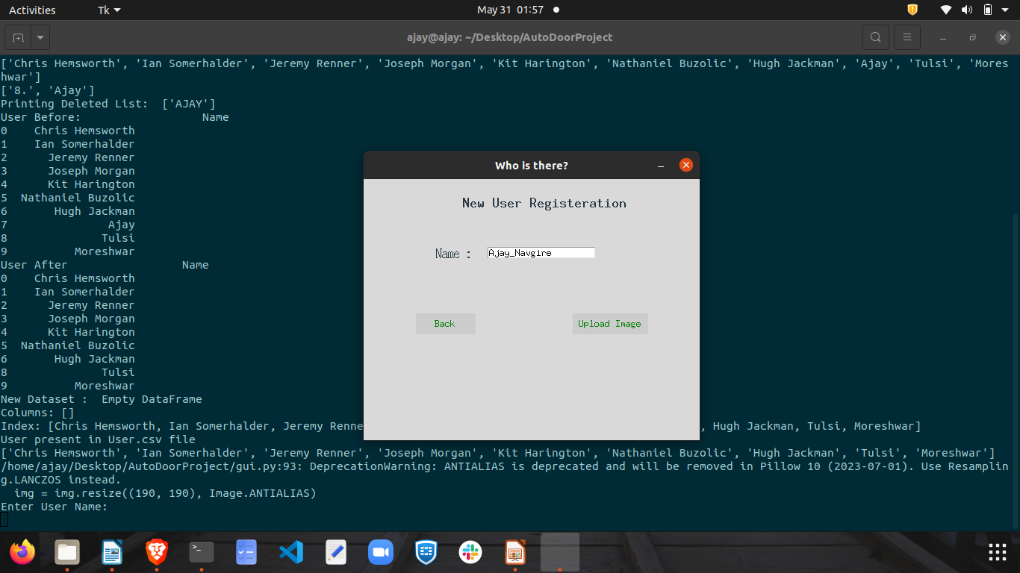

Fig.1.4. Get user user name and image

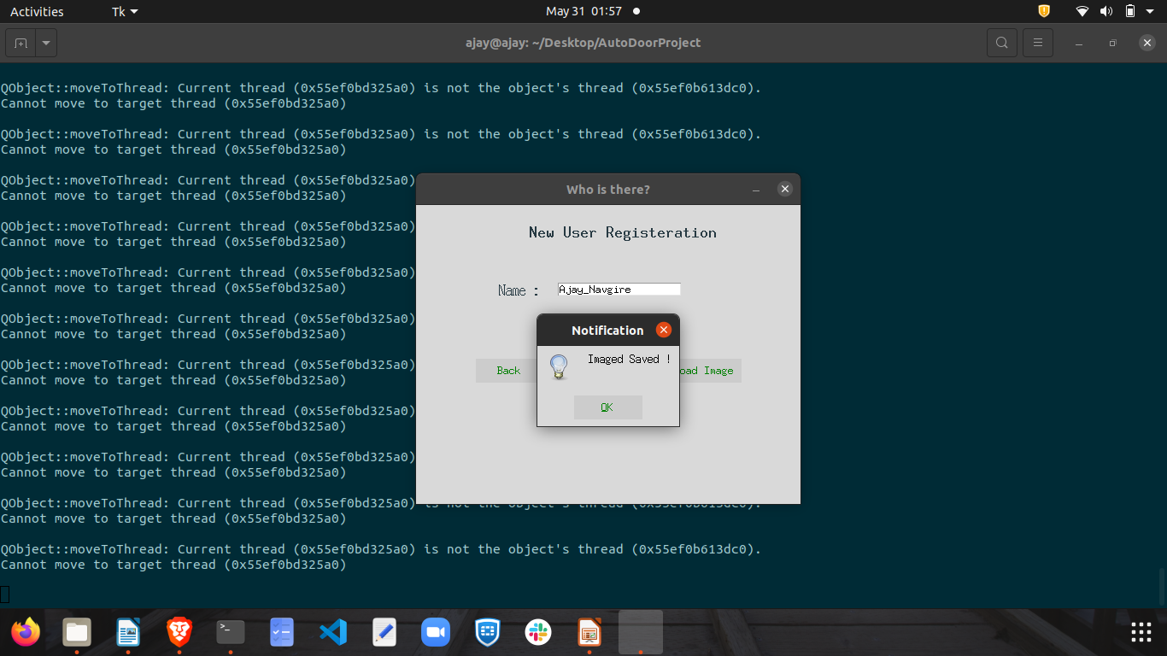

Fig.1.5. Show pop-up message after image saved in folder

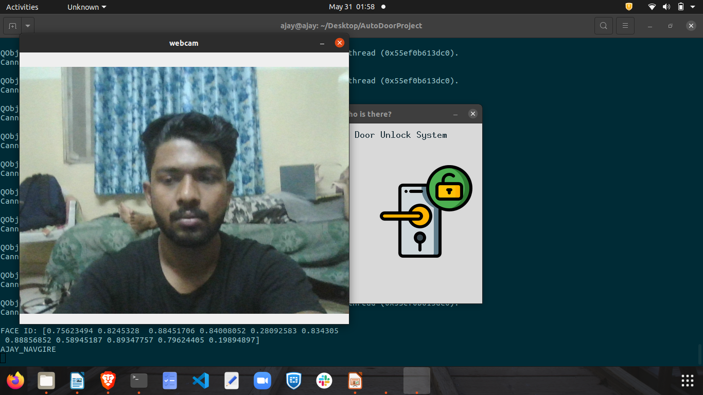

Fig.1.6.Click on doorbell button in order to check person known or unknown

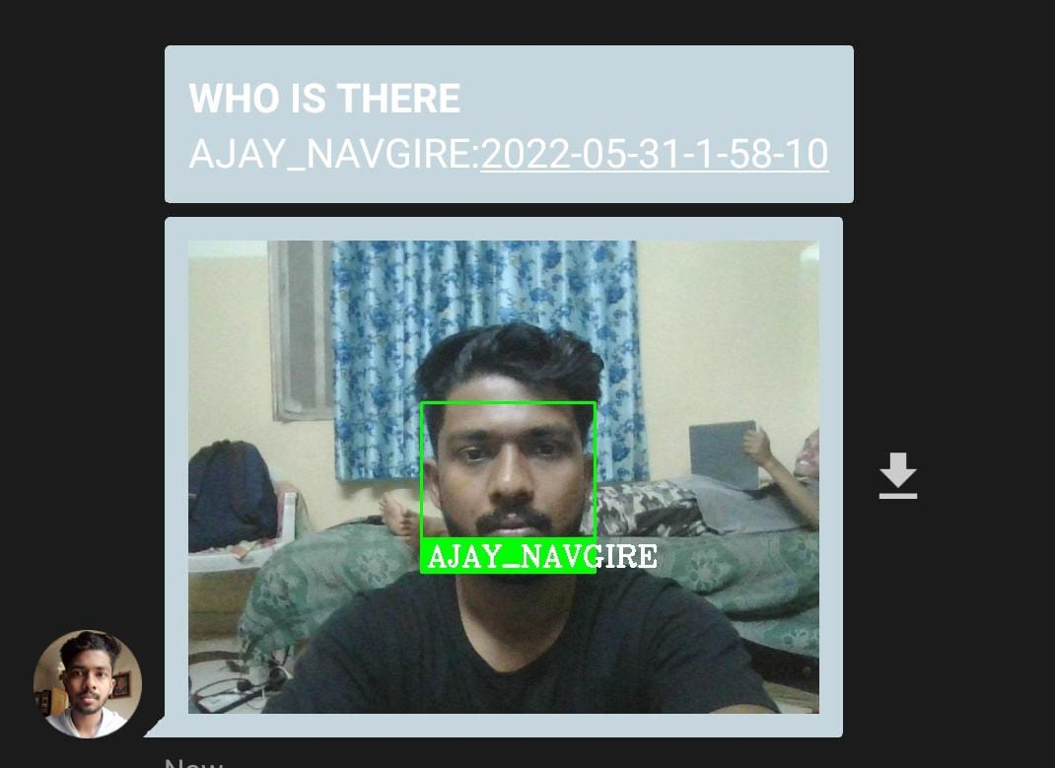

Fig.1.7. Send notification on system owner mobile

7.Project Artifact:
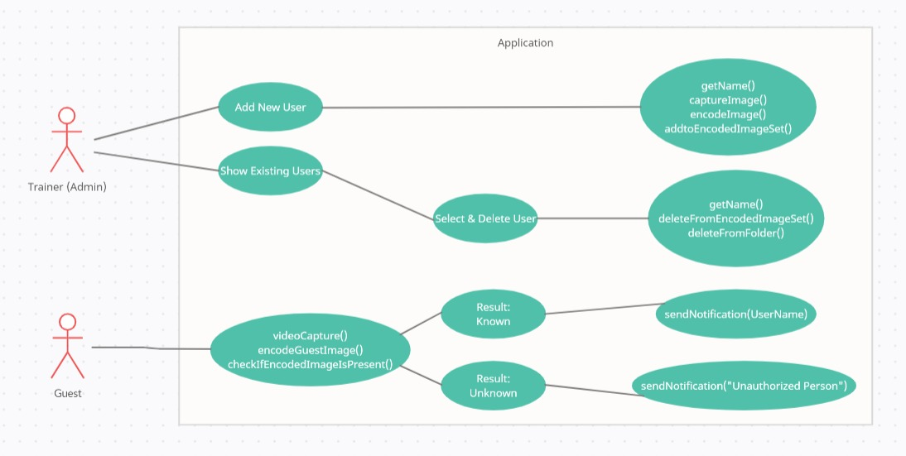

Fig.2.1 Flow of system

Project code:

https://github.com/Ajay2000wce/Final_Year_Project

8.Conclusion and future scope :

8.1 Conclusion

- The Accuracy of for the algorithm is very high, which shows that the LBPH classifier is an efficient and accurate face recognizer
- The algorithm is able to provide access control during different lighting conditions (during day and night) because Haar Cascades frontal profile.
- Although the profile is just for frontal faces it can detect accurately for slight head tilts (about 15 -20 degrees) and at 200 cms distance from webcam.
- The accuracy between lighting conditions and the quality of the webcam used.
- For recognition with even greater confidence, the equipment or environment (web camera and the room light/natural light) should be higher quality.

8.2 Future Scope

- This project can be integrated with raspberry pi for actual implementation on the door.
- This project can be used in drone cams for criminal detection in crowds.
- This project can be implemented over large sectors.
- Can be used for attendance purpose of students.
- Can be used for employee recognition in corporate sectors.
- Can be used to detect security flaws and trespassers.

9. References:

https://www.w3schools.com/python/

https://arsfutura.com/magazine/face-recognition-with-facenet-and-mtcnn/

https://www.tutorialspoint.com/python/python_gui_programming.htm#:~:text=Tkinter%20is%20the%20standard%20GUI,to%20the%20Tk%20GUI%20toolkit.&text=Import%20the%20Tkinter%20module.

https://github.com/ageitgey/face_recognition

https://pythonhosted.org/face_recognition/readme.html

https://opencv24-python-tutorials.readthedocs.io/en/latest/py_tutorials/py_objdetect/py_face_detection/py_face_detection.html

